Figures used in Research Article
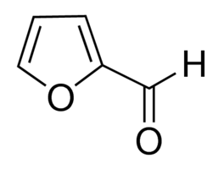
Figure 1. Chemical structure of Furfural

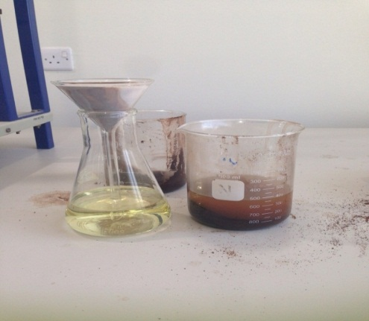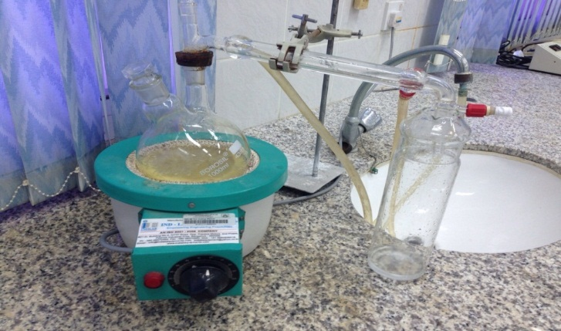
Figure 2 (a): Filter the date seed from solvent n-hexane Figure 2 (b): Simple Distillation

Figure 3. Carbon NMR of the Product
Figure 4. Proton NMR of the Product
Tables used in article
Table 1. Fatty Acid percentage in the date seeds
Type of Fatty Acids | Percentage
Cbric acid | 0.7%
Carrinic acid | 0.5%
Lournic acid | 24.2%
Mirestic acid | 9.3%
Balmatic acid | 9.2%
Ualic/ilmic acid | 25.2%
Citric acid | 03.02%
Table 2. Percentage of Furfural extracted from the different parts of the Palm tree
Palm Tree Part | Furfural percentage
Dates' seeds | 30.00%
stem | 16.70%
Palm | 16.40%
Hmarich | 14.50%
Palm tree fiber | 12.70%
Palm tree trunk | 11.70%
Palm leaves | 08.50%

Table 3. Nutritional composition of the dates' seeds
Substance | Percentage
Carbohydrates | 62.51%
Fibers | 16.20%
Fats | 08.49%
Humidity | 06.46%
Salts | 00.50%
Protein | 00.22%
Others | 05.62%

